Schools can now submit helpline calls directly through the SCC Self Service portal logging requests directly to the Schools and Traded Team, bypassing the Service Desk.

The benefit of this new service is that your calls are immediately available to the Schools and Traded Team and you can track the progress of the call.

If you have previously requested access to Self Service (eg for SIMS or EFS calls) you do not need to request access again as you can access Self Service via the usual link (https://servicedesk.somerset.gov.uk/assystnet/application.jsp#homepage) and the SCC ICT tile set up for logging calls to Schools and Traded will be available to you.

If you have not already set up to log calls on the Self Service portal, complete Step 1.
Instructions on how to log a call on the portal are shown in Step 2.
1) Setting up an account in the SCC Self Service Portal
To request an account to log into Self Service please click the following link, if you work at more than one school you will need a separate account at each school, to do this complete the form when you are logged on to the network at each school:
https://eforms.somerset.gov.uk/selfservice/
Complete your details on the form and click send to submit your request.

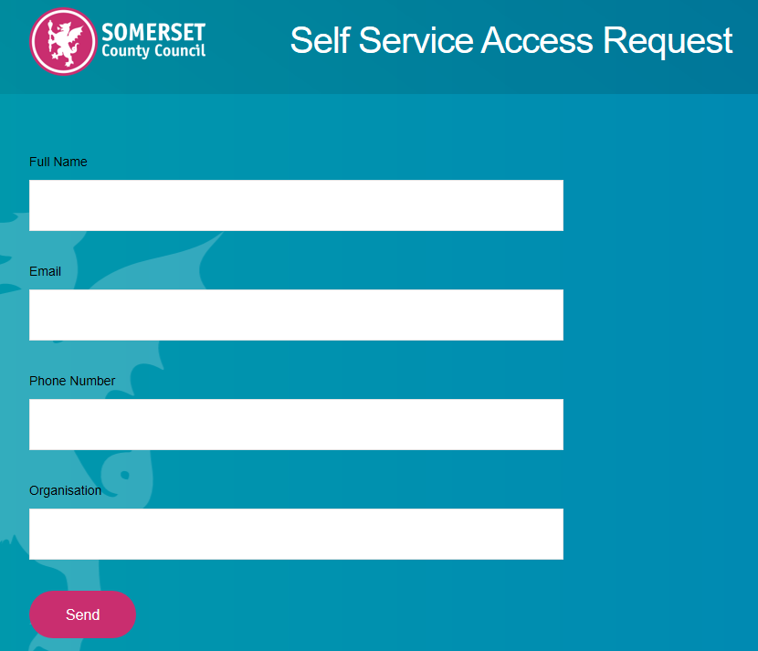

You will receive an email from Somerset ICT Services (azureservices@somerset.gov.uk) requesting that you confirm your registration by verifying your email address.

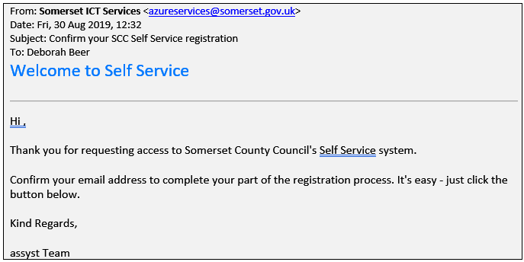

Once you have verified your email, you will receive a further email from Somerset ICT Services to confirm your request is now with the approval team:

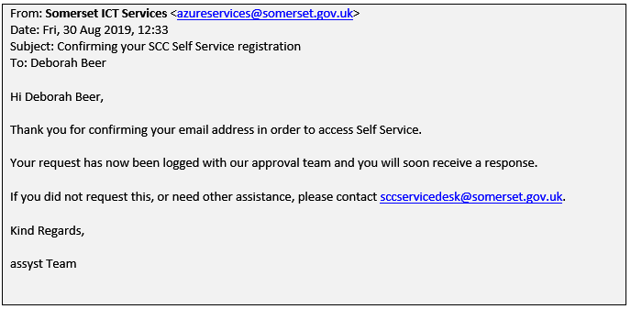

Once approved you will receive another email from Somerset ICT Services to confirm your request has been accepted.

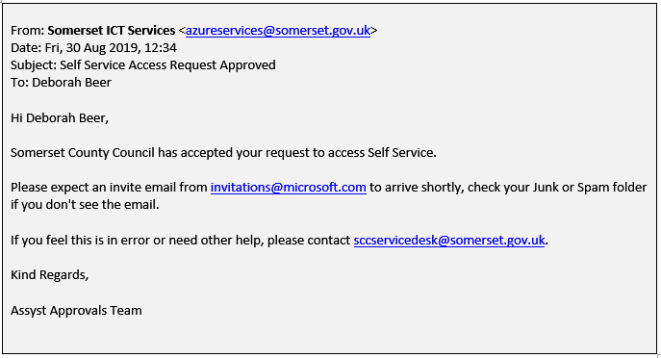

Finally, you will receive an email from Microsoft Invitations (invites@mircosoft.com) confirming you have been invited to access the Somerset County Council Organisation and to click on the Get Started button.

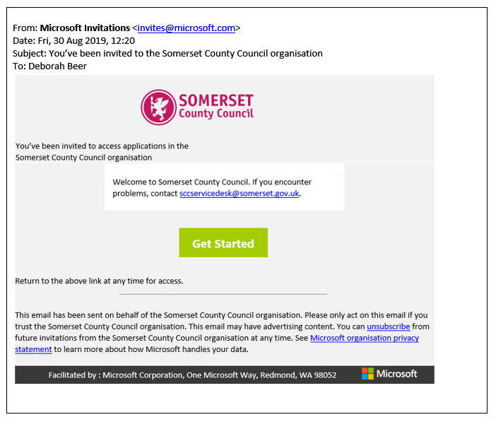

You will need to log in using your email address and password.

Step 2) Using the Self-Service Portal to log calls for Schools and Traded.
Once you have accessed the Self-Service portal please save the webpage address to your desktop or your favourites so that you can easily access the portal in future (you will not be asked to log in again). If you have more than one school account, please do this at each school when you are logged on to the network.

To log a call with Schools and Traded, please click on the Services menu:
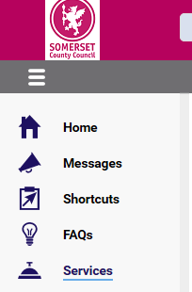

Click on the following tile to access the Schools and Traded Self Service forms.

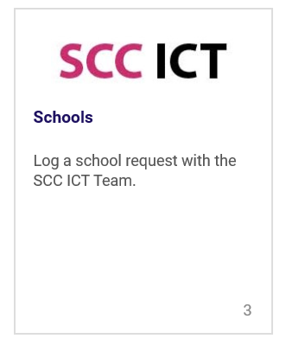

and then choose from the following:
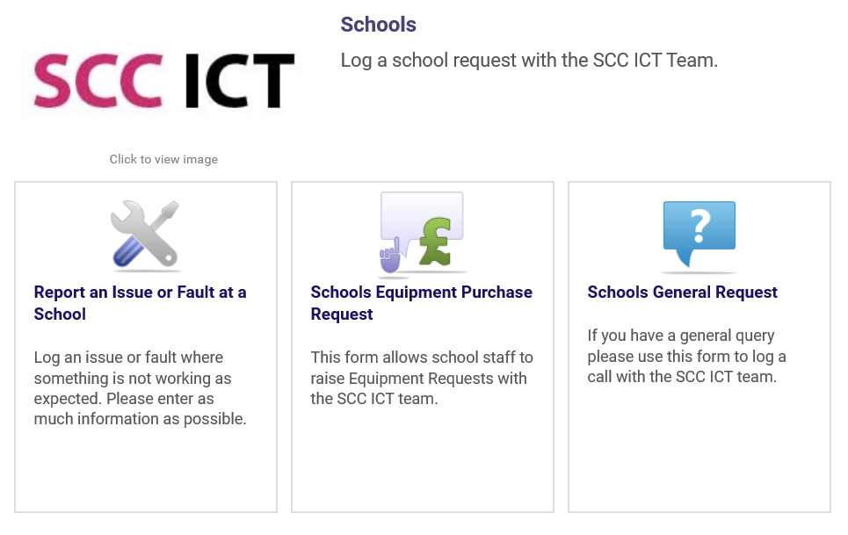

Complete the form and click the submit button to log your call. You will be sent an email with your call reference number and confirmation that your call has been logged.
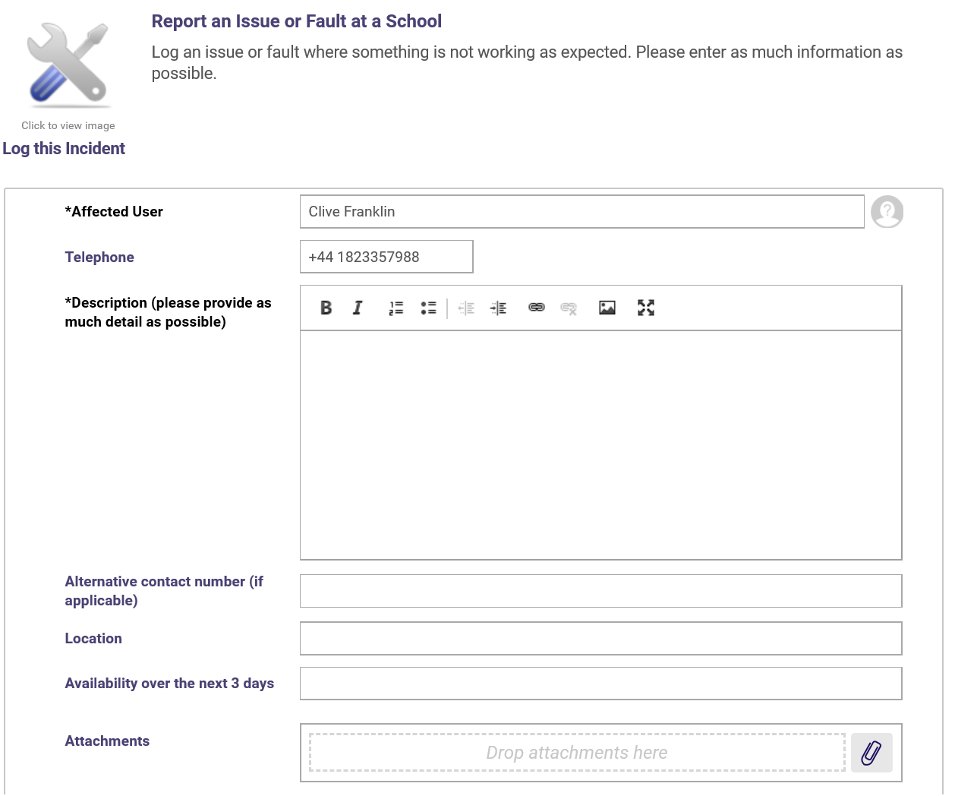
To track the progress of your call, click on Track Progress in left hand menu and then “Open Issues and Faults” or Open Requests for (General Requests and Equipment Purchase Requests). All open calls will be listed.

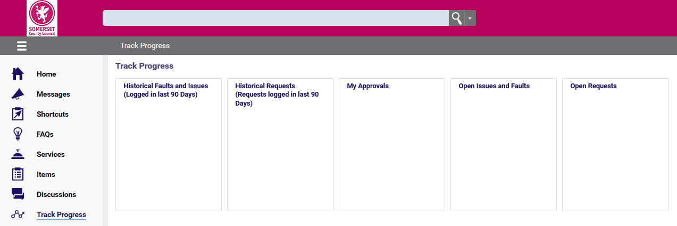

Help

If you move to a new school, please request a new account by following step 1. If your current school changes, its email service and staff are given a new email address then please follow step 1 to request a new account.

If you are unable to get into assyst Self-Service at all then please log a call with the Service Desk on 01823 355090.

